**CSCI 3090: Computer Graphics and Visualization**

**Assignment 3**

**Due Date: April 10, 2018**

The subject of the third Assignment is the visualization of the Solar System based on a Perspective Projection, using OpenGL, C++ and Shaders.

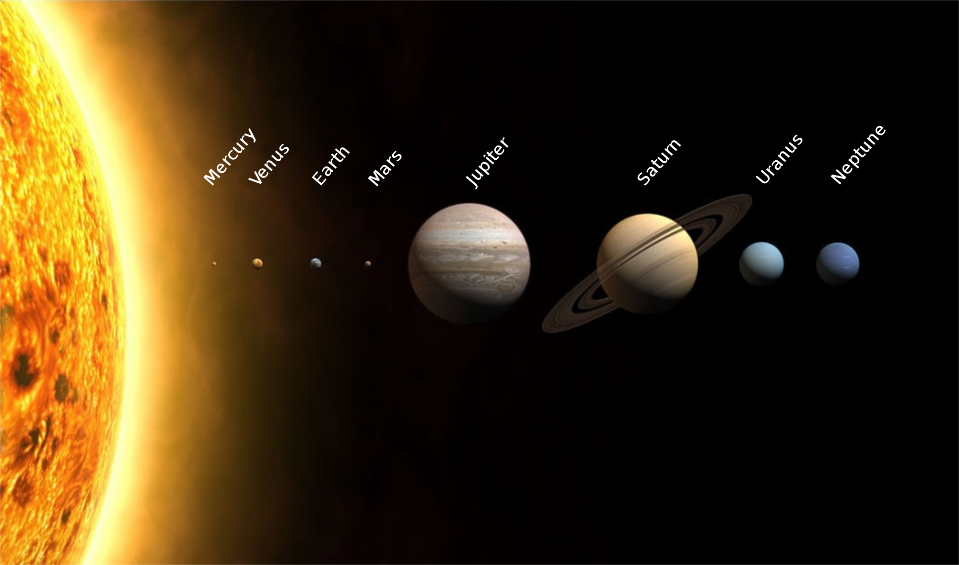

* Create the objects or Import Models of all the planets
* Create the Sun as the center of the Solar System and apply Illumination properties. The Sun will be treated as an immobile object.
* Create at least 5 individual planets (although the inclusion of all the planets is encouraged) trying to simulate its original size, movement, trace and luminosity (apply illumination properties to all planets). Maintain the order of the Planets as it is in our Solar System. Each planet must:
  + Rotate around the Sun.
  + Rotate around its axis.
* The inclusion of Earth as a Planet is mandatory. Implement also its Natural Satellite (Moon). Bind it with the Earth and simulate its rotation around the Earth (Optional: Lock one side of the moon to continuously face the Earth).
* Apply the proper textures for each planet using images (Optional: The seas on earth must applied with a different Light Map that the Continents).
* Do not attempt to represent the actual distances between the planets but make sure that they have enough distance between them allowing them to follow their traces.
* Implement a camera as the Point of View of the use, who is able to move across the scene using the mouse and keyboard keys (a,w,s,d).
* When the P keyboard key is pressed an Asteroid must be launched from random locations of the outer space.
  + Accelerate its speed in order to be able to view it.
  + Create an asteroid trace based on the resources you are provided or found.
  + When the asteroid passes close to a planet change its trace based on the size of the planet only.
  + When the Asteroid collides with a planet, detect the collision and destroy it.
  + The Asteroids must be fat smaller than the planets
* Some resources are listed below but feel free to make your own research.
  + <https://solarsystem.nasa.gov/solar-system/our-solar-system/in-depth/>
  + <https://starchild.gsfc.nasa.gov/docs/StarChild/solar_system_level1/solar_system.html>
  + <https://www.youtube.com/watch?time_continue=345&v=yf6YvGb83H4>
  + <https://www.nasa.gov/moon>
  + <https://www.space.com/51-asteroids-formation-discovery-and-exploration.html>
  + <https://solarsystem.nasa.gov/small-bodies/asteroids/in-depth/>

*Evaluation Criteria*

The maximum grade for this Assignment is 100 and grading is based on the table below:

|  |  |
| --- | --- |
| Criteria | Grades |
| **Successful Compilation:** Your program compiled successfully, and runs without issues on another’s computer. | 10/100 |
| **Projection:** Implementation of Perspective Projection. | 5/100 |
| **Camera:** Proper camera implementation and movement. | 5/100 |
| **Texturing:** Correct and smooth application of the textures on the planet’s surfaces. | 10/100 |
| **Lighting:** The Sun’s and Planet’ luminosity is correctly developed and their effect is applied on other Planets and asteroids with the proper intensity. | 20/100 |
| **Planets (and Moon) Traces and Movement:** Correct movement of the Planets around the Sun and around their axes. | 30/100 |
| **Asteroids Traces, Movement and Collision:** Correct spawning, movement and Collision of the Asteroids. | 20/100 |

The program is expected to be compiled and to be executed producing the proper results. Feel free to discuss about the Assignment with your fellow students but any plagiarism or exchange of code is forbidden. This Assignment can be conducted in **groups of 5**. Make sure that you have included the names of all the members of your group at the top of the code as a comment.

**Good Luck and Have Fun!**